E-newsletter #6 August 2014

Science ASSIST website - fully launched

Over 200 registered users….and counting!

The ASSIST website is fully functioning and at the moment there are over 300 individual resources for teachers and lab techs to access. This includes:
- at least one link to a quality teaching resource for every Science Understanding content descriptor in the Australian Curriculum: Science years F–10. These include:
- Assessment tasks
- Blogs/News articles/Research
- Demonstrations
- Interactives/simulations
- Information sheets
- Lesson plans
- Moodle discussions/forums
- Practical activities/investigations (PRIORITY)
- Presentation slides
- Risk assessments
- Podcasts/audio files
- Teacher background information
- Unit plans
- Videos/animations

- the answers to questions posted on the Q&A section of the website. The answers have been provided by the ASSIST expert groups
- a range of Standard Operating Procedures, information sheets and risk assessments for lab techs

…..and this is being added to on a daily basis!

Science ASSIST at CONASTA 63
A Science ASSIST information session was held at CONASTA 63 in Adelaide. This was very well attended and the ASSIST team were able to guide the participants through the website and the registration process as well as providing information on the entire ASSIST project.

Each of the 500+ delegates were given a colourful Science ASSIST travel mug with the ASSIST website URL clearly displayed around the middle.

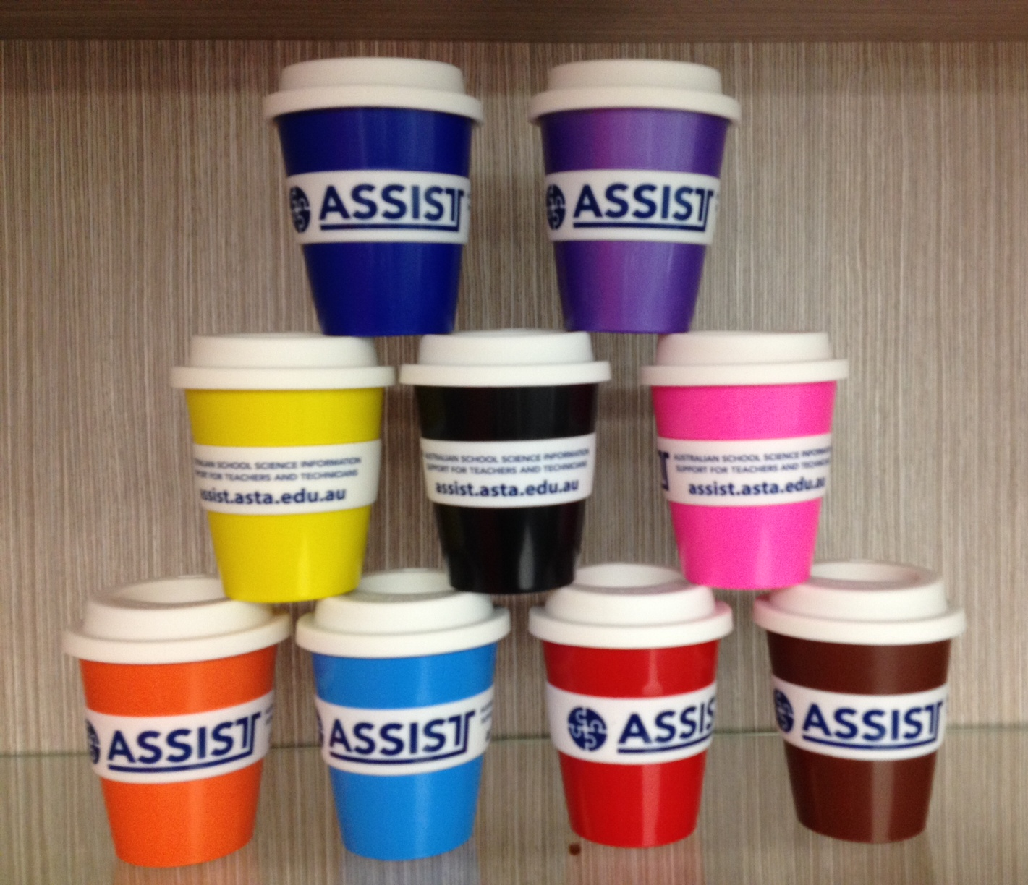

Current and future project activity
For teachers:
- Resource audit
The Science teacher expert group have just completed an audit of the resources on the ASSIST website. The results of the audit will be mapped against a curriculum support map in order to determine what further resources are needed to support each particular content descriptor. The outcome of this mapping exercise will drive future curation and collation of supporting resources as needed.

- Connected Learning Experience (CLE)
One of Science ASSIST’s key aims is to encourage, and provide support for, the use of practical activities in science teaching and learning. In a recent face-to-face strategic meeting of the Project Management Group, it was decided that the best way to achieve this aim was to develop an extensive program of Connected Learning Experiences for teachers of years F–10. CLEs use the practical activity as the cornerstone of the teaching and learning process. Accompanying resources are provided to support the implementation of the practical activity. These will assist teachers maximise the benefit of the activity in the learning program.

For lab techs:
The Lab tech advisory group are continuing to identify and develop Standard Operating Procedures, information sheets and risk assessments. Have you seen the extensive school science suppliers list or the links to the OHS and work safety publications in each state and territory?

As more and more school lab techs become aware of the ASSIST site an increasing number of questions are being asked. It is envisaged that the provision of authoritative advice will take up much of the advisory group’s time in the future.

In the next 6–12 months, ASSIST will be concentrating on developing comprehensive advice and supporting resources on the safety, storage and labelling of approved chemicals for use in schools and on the design of school science facilities (both primary and secondary).

Primary teachers survey
The primary teachers survey is now complete. The final component of the survey, the online questionnaire closed in early July with over 800 respondents. The results from the focus group sessions, the in-depth interviews with rural and remote teachers and the online questionnaire are being collated and a final report written. The results and a link to the report will be provided in the September newsletter.

If you have not already done so, please take a look at the ASSIST website www.assist.asta.edu.au Feedback is welcomed.

Monthly resource highlight
For lab techs:
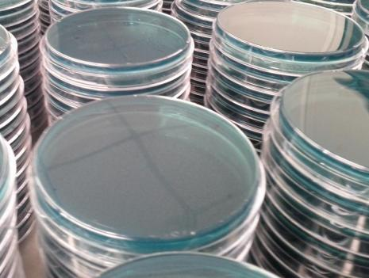
SOP: Preparing agar plates

For teachers:
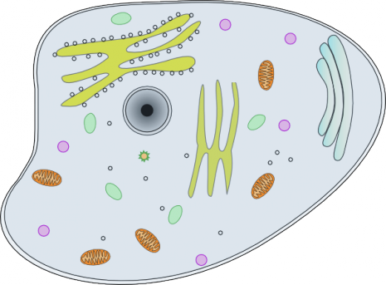
Cells – Yr 8 unit of work (ScienceWeb)

