E – newsletter #4 March 2014

Science ASSIST website training for the expert groups
As reported in the February newsletter, both expert groups have been collecting, collating and preparing to upload resources onto the new Science ASSIST website. On the 15th March, the website training workshop gave members the first chance to interrogate the functionality of the website as well as run through the process of uploading resources.

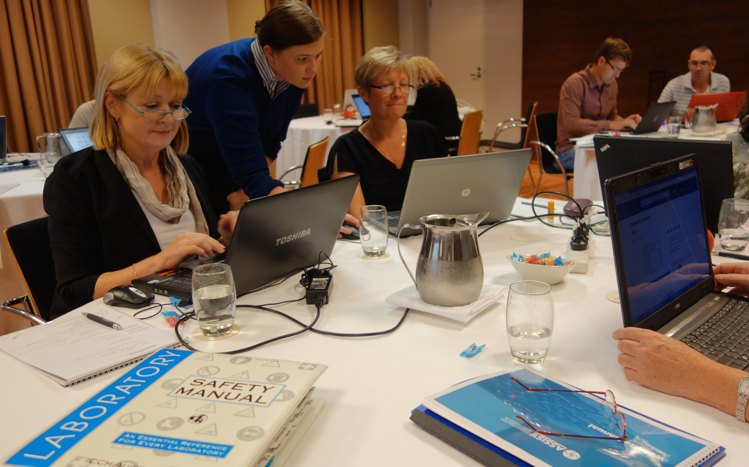

Supported by the web developers, Go1 and ASTA staff, there was a consensus amongst the group that the ASSIST project had just moved up a notch. The website www.assist.asta.edu.au is expected to go live in mid April so that the team can get a better feel on how the site functions and to ensure that internal processes are well honed. The official launch will take place at CONASTA in July (6-9th Adelaide)

Primary teacher survey
The national primary teacher survey (focus groups) is in full swing. Focus groups have been complete in Western Australia, South Australia, ACT and Queensland. The Tasmanian focus group will be conducted this evening leaving only NSW and Victoria to be completed.

The initial feedback has been insightful. Topics unpacked include but were not limited to, resources (including for non specialist teachers), teacher PD, classroom risk management, and competitions.

Two additional elements will complete this research in the coming months:
- 15 in-depth interviews with teachers in rural or remote locations,
- an online national survey open to all primary teachers

The final primary teachers survey report will be available in June and will inform the development of teaching materials, programs and new resources to support primary teachers of science.

April is all about preparing the website for a soft launch.

