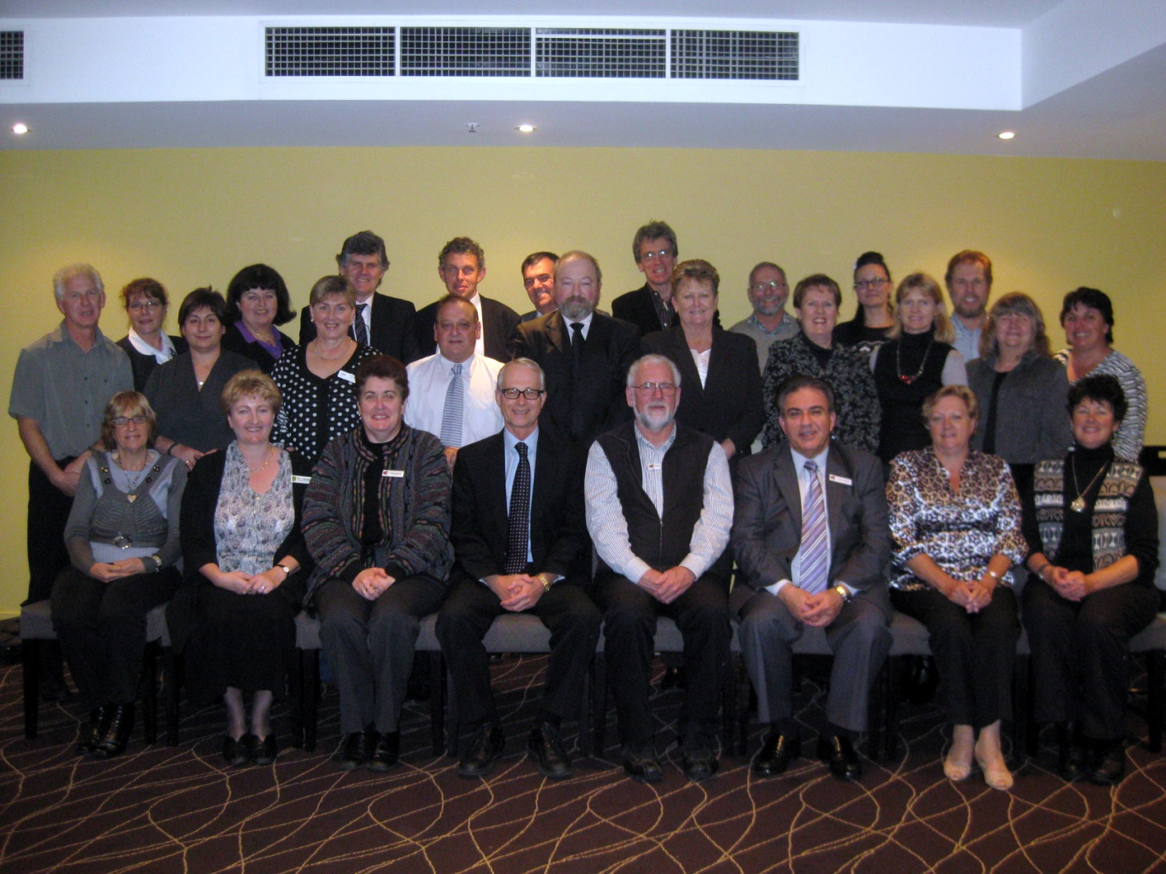
National Science School Laboratory Technicians
Inaugural Forum - Sydney 8 July 2010

Back Row (L to R): Ms Sylvia Towers (SETA, ACT) Ms Jan Brooks (DECS, SA) Mr Sam Vonarx (Centre for Biotech, TAFE Vic), Mr Scott Lambert (DEEWR), Mr Jim Davies (Aus Sec Prin Assoc), Mr John Shanahan (DET, NT), Mr Gary Carey (Cath Ed Office, NSW), Ms Katherine Parker ((DEECD, Vic), Mr David Wintle (DET, ACT), Ms Louise Nielson (DET, WA)
Centre Row (L to R): Mr Dale Carroll (SETA, Vic), Ms Desi Karlovassitis (SETA, SA), Ms Hazel Law (PWAC, SA), Mr Glen Sawle (DET, NSW), Mr Geoff Gleadall (SETA, Vic), Ms Margaret Croucher (SETA, NSW), Ms Jenene Rosser (Ind Sc Council Aus), Ms Toni Fox (DET, Qld), Ms Ruth Kempton (DET(OHS), WA)
Front Row (L to R): Ms Jan McGaw (SETA, Qld), Ms Teresa Gigengack (SETA, WA), Ms Anna Davis (ASTA), Prof Mark Hackling (ECU), Mr Peter Turnbull (ASTA), Mr Peter Russo (ASTA), Ms Marilyn Miles (SETA, WA), Ms Jennifer Westren (SETA, Tas)

Absent: Mr Geoff Quinton (ACARA),

